**Project Title and Tech Stack**

**Box and Inventory Management System for Order Packing**

**🧰 Technology Stack**

**🔹 Frontend: Mobile Interface**

* Framework: *React Native*  
  Open-source framework by Facebook for building cross-platform mobile apps using React.
* Language: *JavaScript*
* Barcode Scanner:  
  • *react-native-camera* – Camera access with flash and autofocus

**🔹 State Management**

* React-Redux + Redux Toolkit

**🔹 Backend & API Communication**

* Custom REST APIs (Assumed)  
  Manages data for boxes, inventory, users, and exports. Enables secure, real-time communication between mobile app and server.
* Axios

**🔹 Utilities & Tools**

* Excel Export:Converts app data into downloadable Excel files using libraries like react-native-excel-export for reporting.
* QR/Barcode Recognition:  
  Supports *EAN13* (retail), *Code128* (inventory), and *QR Codes* (box IDs, actions).
* Camera Enhancements:  
  Flashlight toggle and autofocus aid efficient scanning in low-light areas.

**🔹 Platform**

* Mobile (Android & iOS):  
  Fully optimized for both platforms with adaptive layouts, native performance, and secure camera and storage access

**Overview and Workflow**

**Project Overview:**

This mobile application is designed for warehouse order packing operations. It allows employees to scan barcodes, pack items into boxes, track inventory, and export shipping data efficiently.

**User Workflow:**

1. Employee scans a QR code to create a new box.
2. The box is opened and linked to the employee.
3. Items are scanned using barcodes and added to the box.
4. The employee can remove items if needed.
5. Once packing is completed, the box is closed and locked.
6. Closed boxes can be reviewed and exported.
7. Data is exported with Purchase Order (PO) numbers for logistics.

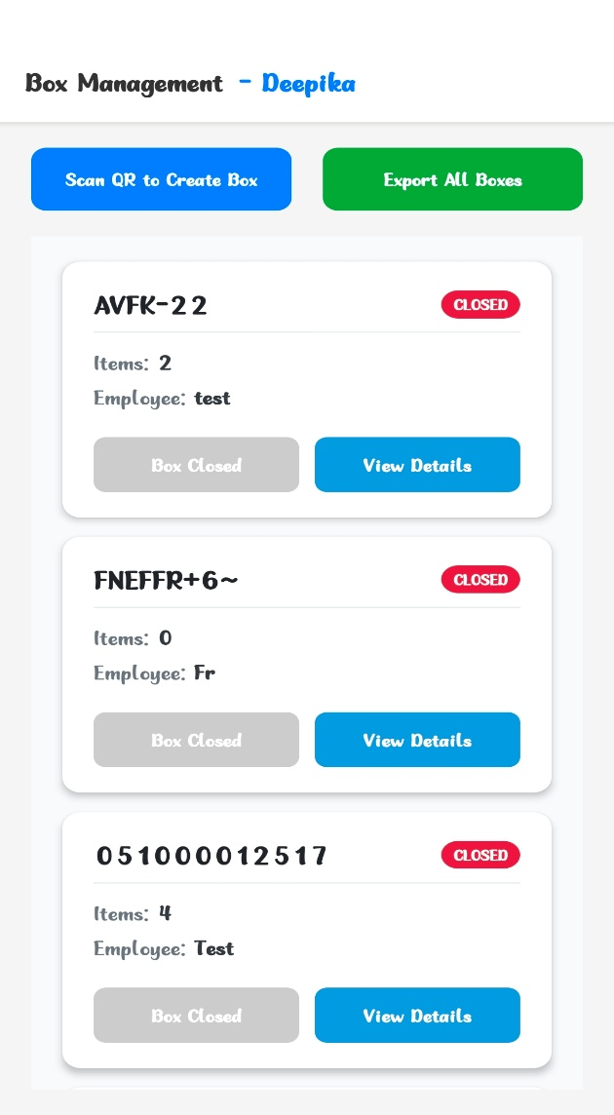

**Box Management**

**Key Features:**

* Scan a QR code to create a new box.
* Assign box to the scanning employee.
* View box metadata including:
  + Box ID
  + Status (Open/Closed)
  + Timestamp
  + Item count
* Close a box when packing is completed.
* Closed boxes are view-only and cannot be modified.

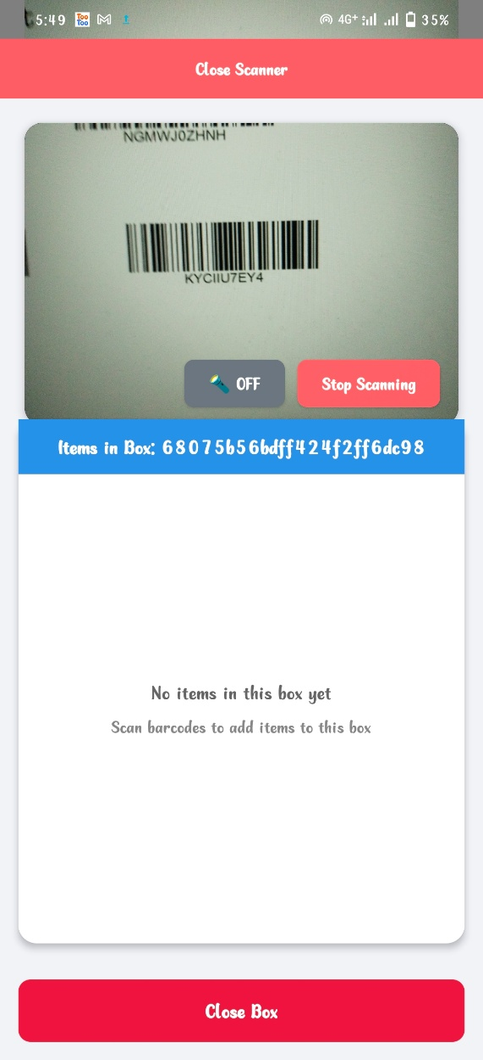

**Item Scanning System**

**Key Features:**

* Use the mobile device camera for scanning.
* Supported barcode formats: QR, EAN13, Code128.
* Real-time scanning with:
  + Audible feedback
  + On-screen confirmation
* Toggle flashlight for low-light scanning conditions.

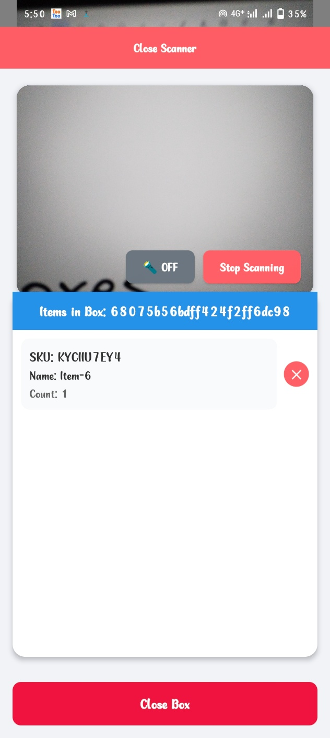

**Inventory Tracking**

**Key Features:**

* Add scanned items to the currently open box.
* Remove items via the UI modal.
* Track item details and count per box.
* Maintain an up-to-date list of inventory in each box.
* Prevent adding items to closed boxes.

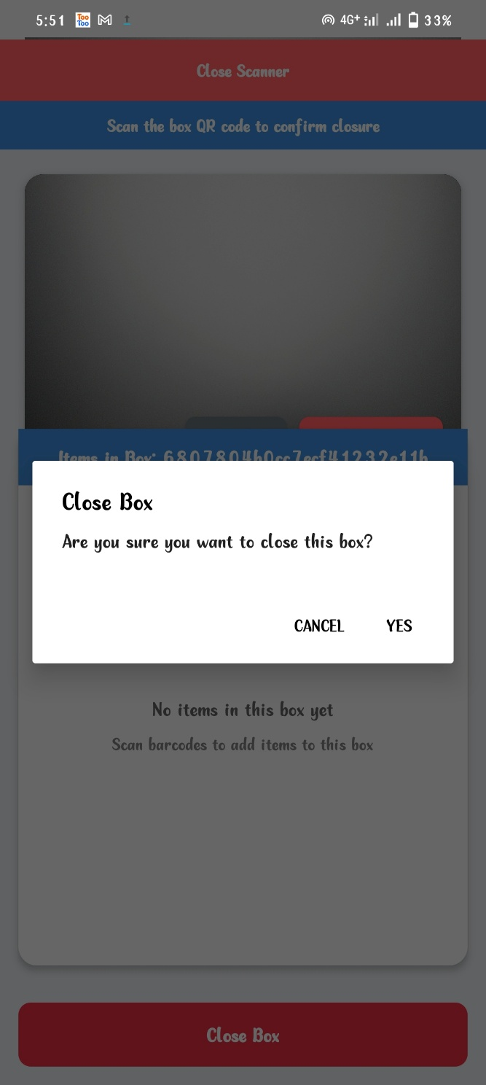

**Export Capabilities**

**Key Features:**

* Export all box and item data.
* Include Purchase Order (PO) number during export.
* Generate Excel-compatible reports for shipping and documentation.
* Supports reporting per box or entire session.

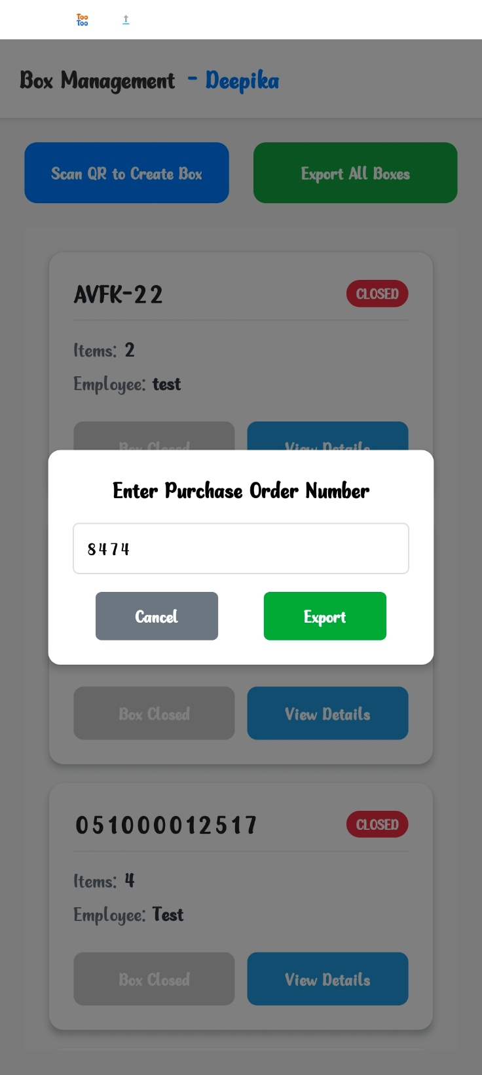

**Conclusions**

**Key Features:**

The Box Management System is a scalable, role-based solution that improves warehouse efficiency and control. It reduces errors, saves time, and boosts productivity through a mobile app for packers and a powerful admin panel for real-time tracking and management.

The system can expand to include dedicated apps for packers, pickers, guards, and a CRM for admins to manage orders, products, and employees — making it a complete, customizable solution for modern warehouse operations.

This helps businesses streamline logistics, improve accountability, and scale operations efficiently across teams and locations.

